# DLink IOS SDK Integration Steps

(Native)

## Versions history

| Index | Date | Change logs |
| --- | --- | --- |
| 1 | 2022/02/22 | Init document |
| 2 | 2022/02/22 | Add some comments |
| 3 | 2022/02/22 | Update github repo |
| 4 | 2022/02/22 | Config support calls feature |
| 5 | 2022/02/22 | Edit Info.plist |
| 6 | 2022/04/06 | Update SDK icon Chat & Call |
| 7 | 2022/06/21 | Show conversation with groupID |
| 8 | 2022/06/28 | Remove key NSUserTrackingUsageDescription  Hiden live location || location  Hiden GPS info |
| 9 | 2022/07/22 | Double push chat  Show Error description |

## Pre Requisites

* + Xcode 13.2.1 (13C100) (exactly version)
  + iOS 10.0 or above
  + Swift version 5 (exactly version)
  + Support bitcode: No
  + Support Features
    - Push notifications
    - Apps groups
    - Associated domains
    - Background modes: Audio, Location updates, Voice over IP, Background fetch, Remote notifications
    - I-cloud
    - Keychains
    - Notification extension service
    - Sharing extension service

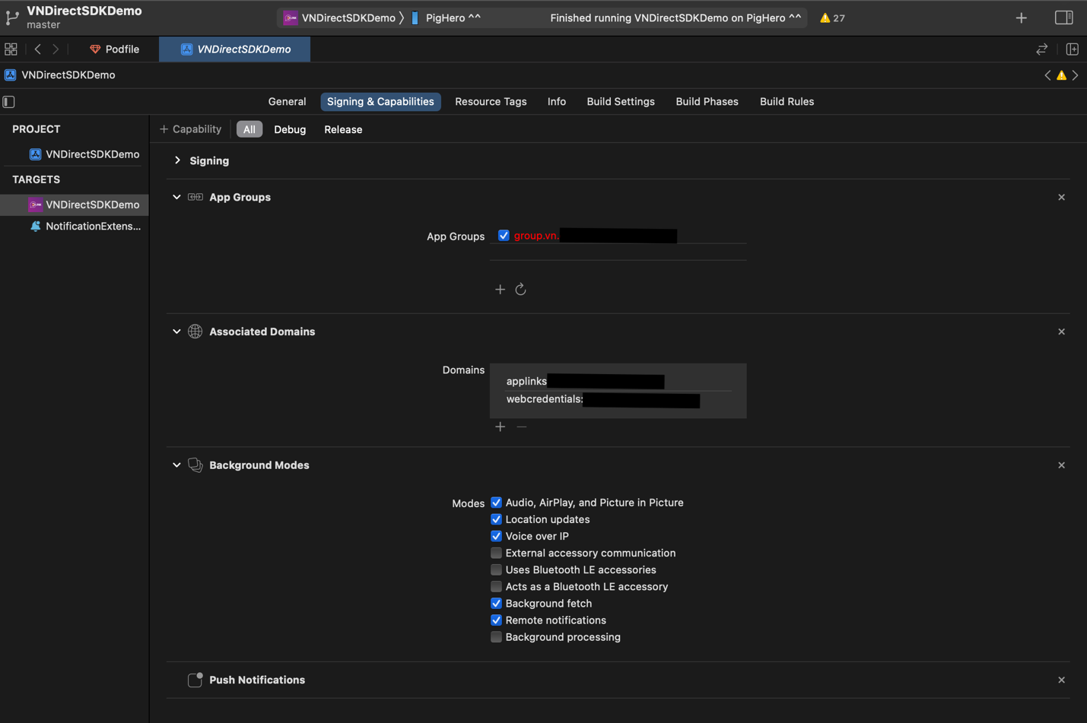

## 1. Add DLink SDK to your project

* **Using Cocoapods**

Integrate Cocoapods <https://guides.cocoapods.org/using/using-cocoapods.html>

// **Edit Pod file**

def rx_swift_pods

pod 'RxSwift', '~> 6.2.0'

pod 'RxCocoa', '~> 6.2.0'

pod 'XCoordinator', '~> 2.0'

pod 'RxGesture', '~> 4.0.2'

pod 'RxRelay', '~> 6.2.0'

end

def rx_swift_noti_pods

pod 'RxSwift', '~> 6.2.0'

pod 'RxCocoa', '~> 6.2.0'

pod 'RxRelay', '~> 6.2.0'

end

def database_pods

pod 'RealmSwift', '10.12.0'

end

def language_pods

pod 'Localize-Swift', :git => 'https://github.com/Netacom-NetAlo/Localize-iOS'

end

def netalo_pods

#switch 1 or 2

# pod 'NetacomSDKs', :git => 'http://github.com/Netacom-NetAlo/NetaloSDKs-iOS', branch: 'YOUR-BRANCH-SIMULATOR'

pod 'NetacomSDKs', :git => 'https://github.com/Netacom-NetAlo/NetaloSDKs-iOS', branch: 'YOUR-BRANCH'

noti_netalo_pods

end

def noti_netalo_pods

#switch 1 or 2

# pod 'NotificationSDK', :git => 'https://github.com/Netacom-NetAlo/NotiSDKs-iOS', branch: 'YOUR-BRANCH-SIMULATOR'

pod 'NotificationSDK', :git => 'https://github.com/Netacom-NetAlo/NotiSDKs-iOS', branch: 'YOUR-BRANCH'

end

def support_noti_pods

pod 'ZIPFoundation', '~> 0.9'

pod 'JitsiMeetSDK', git: 'https://github.com/Netacom-NetAlo/JitsiSDK-iOS.git', branch: 'dev_1.2'

end

def common_pods

pod 'MessageKit', :git => 'https://github.com/ Netacom-NetAlo/Messagekit-iOS'

pod 'SwiftLinkPreview', :git => 'https://github.com/Netacom-NetAlo/SwiftLinkPreview', branch: 'dev_1.0'

pod 'Kingfisher', '6.1.1'

support_noti_pods

end

def tracking_pods

pod 'Firebase/Analytics', '6.21.0'

pod 'Firebase/Crashlytics', '6.21.0'

pod 'FBSDKCoreKit', '8.2.0'

pod 'AppsFlyerFramework', '5.2.0'

pod 'Sentry', :git => 'https://github.com/getsentry/sentry-cocoa.git', :tag => "4.3.1"

end

def secret_pods

pod 'SignalCoreKit', git: 'https://github.com/signalapp/SignalCoreKit.git', :commit => 'eea6884e55261bf157ad6054c72c3c51d7788d4c'

pod 'AxolotlKit', git: 'https://github.com/signalapp/SignalProtocolKit.git', branch: 'master'

pod 'HKDFKit', git: 'https://github.com/signalapp/HKDFKit.git'

pod 'Curve25519Kit', git: 'https://github.com/signalapp/Curve25519Kit'

pod 'GRKOpenSSLFramework', git: 'https://github.com/signalapp/GRKOpenSSLFramework', branch: 'mkirk/1.0.2t'

end

def socket_pods

pod 'Socket.IO-Client-Swift', '14.0.0'

end

def testing_pods

# pod 'Quick', '~> 1.0'

# pod 'Nimble', '~> 7.0'

end

def resolver

pod 'Resolver', tag: '1.4.4', git: 'https://github.com/thanhphong-tran/Resolver'

end

def component_pods

pod 'Carbon', '~> 1.0.0-rc.6'

pod 'Kingfisher', '6.1.1'

end

def gif_pods

pod 'lottie-ios', '3.2.3'

end

# ======================================TARGET PODS==========================================

def app_pods

resolver

rx_swift_pods

component_pods

secret_pods

database_pods

language_pods

tracking_pods

socket_pods

common_pods

netalo_pods

gif_pods

end

target 'VNDirectSDKDemo' do

app_pods

end

# ============================Notification Extension================================

def app_notification_pods

database_pods

rx_swift_noti_pods

resolver

noti_netalo_pods

secret_pods

socket_pods

language_pods

support_noti_pods

end

target 'NotificationExtension' do

app_notification_pods

end

# ============================Share Extension=======================================

# Disable Bitcode because of JitsiMeetSDK

post_install do |installer|

installer.pods_project.targets.each do |target|

target.build_configurations.each do |config|

config.build_settings['ENABLE_BITCODE'] = 'NO'

config.build_settings['ARCHS'] = 'arm64 x86_64'

end

end

end

Replace the YOUR-BRANCH in actual implement

**// Info.plist**

Edit Info.plist File (See demo for more details)

**<key>**NSCameraUsageDescription**</key>**

**<string>**Sending photo and video call**</string>**

**<key>**NSContactsUsageDescription**</key>**

**<string>**NetAlo will continously upload your contacts to its heavily encrypted cloud servers to let you connect with your friends quickly**</string>**

**<key>**NSLocationAlwaysAndWhenInUseUsageDescription**</key>**

**<string>**If you’d like to share your Location with friends, DLink needs location access to use this feature**</string>**

**<key>**NSLocationAlwaysUsageDescription**</key>**

**<string>**If you’d like to share your Live Location with friends, DLink needs location access when the app is in background**</string>**

**<key>**NSLocationWhenInUseUsageDescription**</key>**

**<string>**If you’d like to share your Location with friends, DLink needs location access to use this feature**</string>**

**<key>**NSMicrophoneUsageDescription**</key>**

**<string>**Using voice call**</string>**

**<key>**NSPhotoLibraryUsageDescription**</key>**

**<string>**Sending photo and updating your profile**</string>**

* **Install dependencies**

pod install

## 2. Initialization of SDK

* **Prepare configurations**
  + AppBundle (ID, AppGroupID, Push P12)
    - ID: The unique ID register from apple developer portal. Ref: <https://developer.apple.com/library/archive/documentation/General/Conceptual/DevPedia-CocoaCore/AppID.html>
    - AppGroupID: The ID from app group feature in apple developer portal. Ref: <https://developer.apple.com/documentation/bundleresources/entitlements/com_apple_security_application-groups>
    - Push P12: The exported certificates use for push notifications. Ref: <https://developer.apple.com/documentation/usernotifications/setting_up_a_remote_notification_server/establishing_a_certificate-based_connection_to_apns>
  + DLink App (id, key, adminKey): Request DLink team to provide this information
  + Regis your app with DLink team: Provide the information in AppBundle to register your app to work with DLink ecosystem

* **Import SDK**

import NetAloFull

* **Pre-defined environments**  
  struct BuildConfig {

static var config = NetaloConfiguration(

enviroment: .production,

appId: "**YOUR-APP-ID**",

appKey: "**YOUR-APP-KEY**",

accountKey: "**YOUR-ACCOUNT-KEY**",

appGroupIdentifier: "**YOUR-APP-GROUP**",

storeUrl: URL(string: "https://apps.apple.com/vn/app/vndirect/id1594533471")!,

analytics: [],

featureConfig: FeatureConfig(

user: FeatureConfig.UserConfig(

forceUpdateProfile: false,

allowCustomUsername: false,

allowCustomProfile: false,

allowCustomAlert: false,

allowAddContact: false,

allowBlockContact: false,

allowSetUserProfileUrl: false,

allowEnableLocationFeature: false,

allowTrackingUsingSDK: false,

isHiddenEditProfile: true,

allowAddNewContact: false,

allowEditContact: false

),

chat: FeatureConfig.ChatConfig(

isVideoCallEnable: true,

isVoiceCallEnable: true,

isHiddenSecretChat: true

),

isSyncDataInApp: true,

allowReferralCode: false,

searchByLike: true,

allowReplaceCountrycode: false,

isSyncContactInApp: true

),

permissions: []

)

}

**// Implement user**

NetAloUserHolder(

id: 1234566789,

phoneNumber: "**your-phone**",

email: "",

fullName: "**your-Name**",

avatarUrl: "",

session: "**token-key**")

Replace the YOUR-APP-ID, YOUR-APP-KEY, YOUR-ACCOUNT-KEY, YOUR-APP-GROUP in the following code snippet with the actual appId, appKey, accountKey, appGroupIdentifier

* **Init the SDK**

@main

class AppDelegate: UIResponder, UIApplicationDelegate, UNUserNotificationCenterDelegate {

// MARK: Stored properties

private lazy var mainWindow = UIWindow(frame: UIScreen.main.bounds)

public var netAloSDK: NetAloFull!

private var disposeBag = DisposeBag()

// MARK: - Application Delegate

func application(_ application: UIApplication, didFinishLaunchingWithOptions launchOptions: [UIApplication.LaunchOptionsKey: Any]?) -> Bool {

self.netAloSDK = NetAloFull(

config: BuildConfig.config

)

// Only show SDK after start success, Waiting maximun 10s

self.netAloSDK

.start()

.timeout(.seconds(10), scheduler: MainScheduler.instance)

.catchAndReturn(())

.withUnretained(self)

.observe(on: MainScheduler.instance)

.do(onNext: { (owner, _) in

// Init rooter

let mainTabBarController = DemoMainTabbarVC()

mainTabBarController.initialize(sdk: owner.netAloSDK)

owner.netAloSDK.buildSDKModule()

owner.mainWindow.rootViewController = mainTabBarController

owner.mainWindow.makeKeyAndVisible()

//TODO -Make sure client must login successed to set user info here

owner.setUser()

})

.subscribe()

.disposed(by: disposeBag)

// Optional use notification

self.netAloSDK.requestNotificationtPermission()

UNUserNotificationCenter.current().delegate = self

return netAloSKD.application(application, didFinishLaunchingWithOptions: launchOptions)

}

public func setUser() {

let user = NetAloUserHolder(

id: 1234566789,

phoneNumber: "**your-phone**",

email: "",

fullName: "**your-name**",

avatarUrl: "",

session: "**Token-key**")

do {

try self.netAloSDK.set(user: user)

} catch let e {

print("Error \(e)")

}

bindingService()

}

// MARK: - AppDelegateViewModelOutputs

public func applicationDidBecomeActive(_ application: UIApplication) {

netAloSDK.applicationDidBecomeActive(application)

}

public func applicationWillResignActive(_ application: UIApplication) {

netAloSDK.applicationWillResignActive(application)

}

public func applicationWillTerminate(_ application: UIApplication) {

netAloSDK.applicationWillTerminate(application)

}

func application(_ application: UIApplication, supportedInterfaceOrientationsFor window: UIWindow?) -> UIInterfaceOrientationMask {

netAloSDK.application(application, supportedInterfaceOrientationsFor: window)

}

// UserActivity

func application(_ application: UIApplication, continue userActivity: NSUserActivity, restorationHandler: @escaping ([UIUserActivityRestoring]?) -> Void) -> Bool {

netAloSDK.application(application, continue: userActivity, restorationHandler: restorationHandler)

}

// Notification methods

public func application(_ application: UIApplication, didRegisterForRemoteNotificationsWithDeviceToken deviceToken: Data) {

netAloSDK.application(application, didRegisterForRemoteNotificationsWithDeviceToken: deviceToken)

}

func application(_ application: UIApplication, open url: URL, sourceApplication: String?, annotation: Any) -> Bool {

netAloSDK.application(application, open: url, sourceApplication: sourceApplication, annotation: application)

}

func application(_ app: UIApplication, open url: URL, options: [UIApplication.OpenURLOptionsKey : Any] = [:]) -> Bool {

netAloSDK.application(app, open: url, options: options)

}

// MARK: - UNUserNotificationCenterDelegate

public func userNotificationCenter(_ center: UNUserNotificationCenter, willPresent notification: UNNotification, withCompletionHandler completionHandler: @escaping (UNNotificationPresentationOptions) -> Void) {

netAloSDK.userNotificationCenter(center, willPresent: notification, withCompletionHandler: completionHandler)

}

public func userNotificationCenter(_ center: UNUserNotificationCenter, didReceive response: UNNotificationResponse, withCompletionHandler completionHandler: @escaping () -> Void) {

netAloSDK.userNotificationCenter(center, didReceive: response, withCompletionHandler: completionHandler)

}

}

* **Set current user (Required)**

public func setUser() {

let user = NetAloUserHolder(

id: 1234566789,

phoneNumber: "**your-phone**",

email: "",

fullName: "**your-name**",

avatarUrl: "",

session: "**Token-key**")

do {

try self.netAloFull.set(user: user)

} catch let e {

print("Error \(e)")

}

bindingService()

}

* **Handle NetAloSDK delegates (Required)**

**//MARK: SDK call back**

extension AppDelegate {

//SDK binding service

private func bindingService() {

self.netAloSDK.eventObservable

.asDriverOnErrorJustSkip()

.drive(onNext: { [weak self] event in

guard let self = self else { return }

dump("Event \(event)")

switch event {

case .pressedUrl(let url):

dump("PressedUrl: \(url)")

case .mediaURL(let imageUrls, let videoUrls):

dump("Images: \(imageUrls)")

dump("Video: \(videoUrls)")

case .checkUserIsFriend(let userId):

dump("Check Chat with: \(userId)")

case .didCloseSDK:

dump("didCloseSDK ")

case .pressedCall(let type):

dump("pressedCall type: \(type)")

case .sessionExpired:

dump("sessionExpired")

case .updateBadge(let badge) :

dump("updateBadge: \(badge)")

default: break

}

})

.disposed(by: disposeBag)

}

}

## 3. Use SDK DLink

* **Open list Group:**

self.netaloSDK?.showVNDemoVC(completion: { error in

let err = error as? NAError

print("showVNDemoVC with err: \(err?.description ?? "")")

})

* **Open chat 1-1 (with user want to chat):**

let testContact = NAContact(id: 123456, phone: "phone", fullName: "fullname", profileUrl: "url")

self.netaloSDK?.showChat(with: testContact, completion: { error in

let err = error as? NAError

print("showChat with err: \(err?.description ?? "")")

})

* **Open call (with user want to call):**

let testContact = NAContact(id: 123456, phone: "phone", fullName: "fullname", profileUrl: "url")

self.netaloSDK?.showCall(with: testContact, isVideoCall: false)

* **SEND MESSAGE FUNCTION:**

self.netaloSDK?.sendMessage(content: "SDK TEST SEND MESSAGE", targetUserID: "281474977725116", completion: { _status in

print("SDK TEST SEND STATUS: \(_status)")

})

* **Open conversation with groupID:**

self.netaloSDK?.showGroupChat(with: {GROUPID}, completion: { error in

let err = error as? NAError

print("showGroupChat with err: \(err?.description ?? "")")

})

**Caution:**

Parameters:

+ id: TargetUserID

+ phone: **TargetPhone** Or **TargetUserName**

+ fullName: TargetFullName

+ profileUrl: TargetProfileUrl

* **Logout:**

netAloSDK?.Logout()

## 4. Use Push Notification (For calls & messages)

* **Config builds**

Please follow **Section 2**

* **Config extension (For messages)**

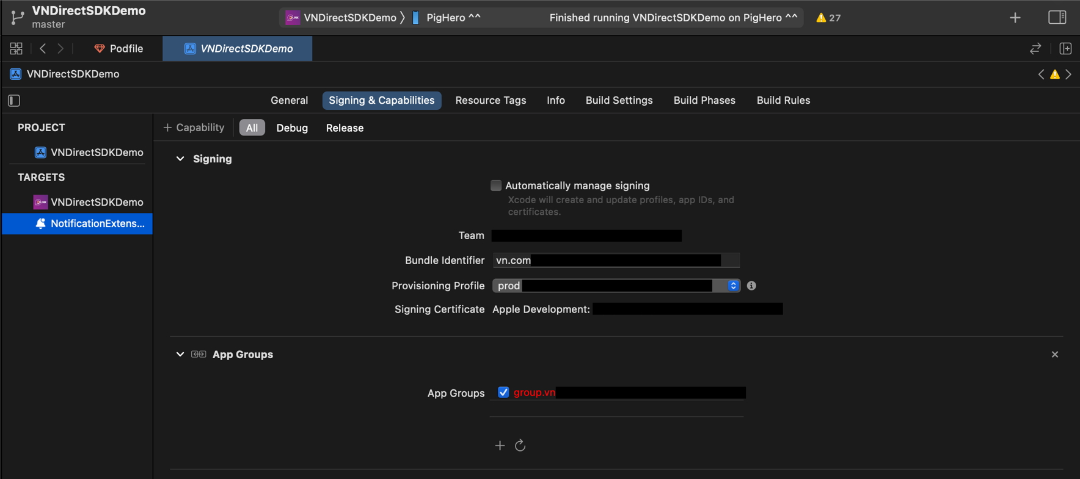

* **Pre-defined environments**

**// BuildConfig.swift**

import NetAloLite

struct BuildConfig {

static var enviroment = EnvironmentType.production

static var appGroupId = "APP-GROUP" // note: same with main app

* **Init the SDK**

**// Injection.swift**

import Resolver

import NotificationComponent

extension Resolver: ResolverRegistering {

public static func registerAllServices() {

register { NotificationComponentImpl(enviroment: BuildConfig.enviroment, appGroupId: BuildConfig.appGroupId) as NotificationComponent }

.scope(.cached)

}

}

// **NotificationService**.swift

} import UserNotifications

import RxSwift

import Resolver

import NotificationComponent

class NotificationService: UNNotificationServiceExtension {

var contentHandler: ((UNNotificationContent) -> Void)?

var bestAttemptContent: UNMutableNotificationContent?

private var disposeBag = DisposeBag()

@LazyInjected private var notificationRepo: NotificationComponent

override init() {

super.init()

notificationRepo.initialize()

}

override func didReceive(_ request: UNNotificationRequest, withContentHandler contentHandler: @escaping (UNNotificationContent) -> Void) {

self.contentHandler = contentHandler

bestAttemptContent = (request.content.mutableCopy() as? UNMutableNotificationContent)

if let bestAttemptContent = bestAttemptContent {

notificationRepo.replace(oldContent: bestAttemptContent)

.do(onSuccess: { (newContent) in

contentHandler(newContent)

})

.subscribe()

.disposed(by: disposeBag)

}

}

override func serviceExtensionTimeWillExpire() {

// Called just before the extension will be terminated by the system.

// Use this as an opportunity to deliver your "best attempt" at modified content, otherwise the original push payload will be used.

if let contentHandler = contentHandler, let bestAttemptContent = bestAttemptContent {

contentHandler(

notificationRepo.expired(oldContent: bestAttemptContent)

)

}

}

}

* **Change sound ring notification**

Use file: notification_sound.wav

if not found sound ring use default device.

## 5. Use Option SDK DLink

* **Custom Theme color for app**

Currently iOS SDK does not support config Theme. So each theme will have a custom build.

* **Block/Unblock User**

netAloSDK. blockUser(blockedID: "USER_ID", completion: @escaping (Bool) -> Void)

netAloSDK.unBlockUser(blockedID: "USER_ID", completion: @escaping (Bool) -> Void)

* **Set Language**

netAloSDK.setLanguage(language: String)

## 6. Contact

Email: [sondh@netacom.vn](mailto:sondh@netacom.vn)

iOS developer

Mobile: (+84) 906600132

Headquarters:

5 Dien Bien Phu St., Dien Bien Ward, Ba Dinh District, Hanoi City, Vietnam

Ho Chi Minh City Office:

Ground Floor, Centre Point Tower, 106 Nguyen Van Troi St., Ward 8, Phu Nhuan District, HCMC, Vietnam.

## 7. Example

<https://github.com/Netacom-NetAlo/DLinkSDK-iOS-Demo>